Measuring GRAVITATIONAL POTENTIAL ENERGY
TASK: Measure the GPE object and how well it converts to Kinetic energy
A very simple science report has been already started for you – see below. You need to complete the report. While this task is simple, the skills you develop will be useful in later experiments. The parts you need to do are…
- make up a suitable method (see the results table for clues)
- Collect results neatly and calculate GPE and Kinetic energy
- Graph the dependant variables against the independent variable.
Aim: To measure how GPE and kinetic energy are connected.
Variables: Independent (2) = Height of the object
Dependant = Gravitational Potential Energy of the object
Controlled = _______________________________________________
Hypothesis: The higher the object, and the GPE it has, and the greater the Kinetic Energy it will have at the bottom of the ramp. This is because GPE is converted to KE as the ball rolls down the ramp.
Method:
MATERIALS

- Large marble or tennis ball
- Ruler
- Stopwatch
- Metre ruler
- Electronic balance

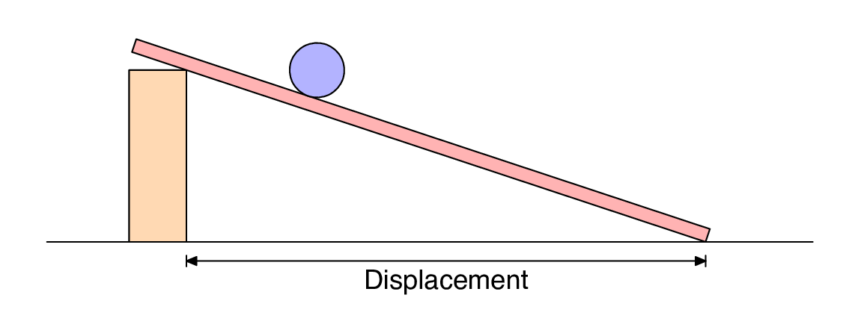


2 m
ht
METHOD:
- __________________________________________________________________
- __________________________________________________________________
- __________________________________________________________________
- __________________________________________________________________
- __________________________________________________________________
- __________________________________________________________________
- __________________________________________________________________
Results:
Table1: GPE and Kinetic Energy of a rolling object.
Object Height, h (in m) | Mass, m (in kg) | GPE (J)  $$GPE=m×9.8×h$$ | Time (seconds) |  |  |  | Distance rolled(m) | Velocity, v (m/s)  Dist / time | Kinetic Energy (J)  KE = ½ x m x v²
Object Height, h (in m) | Mass, m (in kg) | GPE (J)  $$GPE=m×9.8×h$$ | Trial 1 | Trial 2 | Trial 3 | Average | Distance rolled(m) | Velocity, v (m/s)  Dist / time | Kinetic Energy (J)  KE = ½ x m x v²

Graph1: GPE versus the Height
.

Questions
1. Describe the trend in the data shown in the graph or table above.
2. Calculate the efficiency of the ramp in converting GPE into Kinetic energy using the table below.
GPE (J)  From the table, write the GPE’s in here again | Kinetic Energy, KE (J)  From the table, write the KE’s in here again | Efficiency (%)  $$Efficiency= \frac{GPE}{KE}×100$$ | Average Efficiency of the ramp (%)

